**CSCI 333 Assignment 02**

**Control Structures and Loops**

1. **Write while loops that prints**

**Source code of the project**

**n=150**

**#1.a All squares less than n.**

**print ("All squares less than", n )**

**a = 0**

**while(a*a<n):**

**print(a*a)**

**a+=1**

**print()**

**#1.b All positive numbers that are divisible by 10 and less than n.**

**print ("All positive numbers that are divisible by 10 and less than", n )**

**num = 10 # Start with the first number that is divisible by 10**

**while num < n:**

**print(num)**

**num += 10**

**print()**

**#1.c All powers of two less than n.**

**print ("All powers of two less than", n )**

**power = 1 # Start with the first power of two (2^0)**

**while power < n:**

**print(power)**

**power *= 2**

**print()**

* **Screenshot of the output**

**1.a**

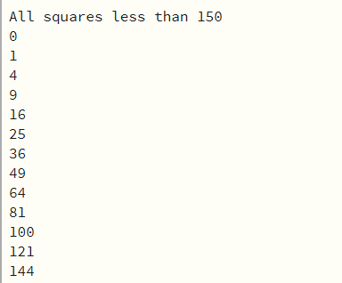

**1.b**

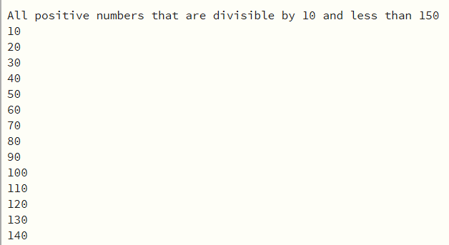

1.c

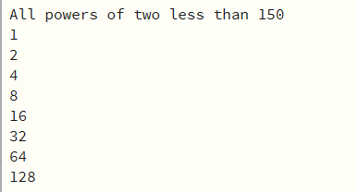

1. **Write for loops that computer**

**Source code of the project**

**#2.a The sum of all even numbers between 2 and 100 (inclusive).**

**sum = 0**

**for num in range(2, 101, 2):**

**sum += num**

**print("Sum of even numbers between 2 and 100 (inclusive):", sum)**

**#2.b The sum of all squares between 1 and 100 (inclusive).**

**sum_sqr = 0**

**for num in range(1, 101):**

**sum_sqr += num ** 2**

**print("Sum of squares between 1 and 100 (inclusive):", sum_sqr)**

**#2.c The sum of all odd numbers between a and b (inclusive).**

**# Assuming a and b are the lower and upper bounds of the range**

**a = 1**

**b = 100**

**sum_odd = 0**

**for num in range(a, b + 1):**

**if num % 2 != 0: # Check if the number is odd**

**sum_odd += num**

**print("Sum of odd numbers between {} and {} (inclusive): {}".format(a, b, sum_odd))**

**#2.d The sum of all odd digits of n. (For example, if n is 32677, the sum would be 3 + 7 + 7 = 17.)**

**num= n = 587283**

**num_odd = 0**

**while n > 0:**

**digit = n % 10**

**if digit % 2 != 0:**

**num_odd += digit**

**n //= 10**

**print("Sum of odd digits of", num,"is",num_odd)**

* **Screenshot of the output**

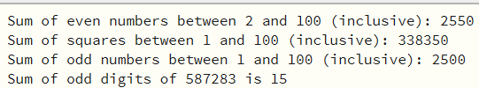

1. **Write a program that generates 100 random numbers in the range of 1 through 1000 and keeps a count of how many of those random numbers are even, and how many of them are odd**

**Source code of the project**

**import random**

**# Function validate if the first argument is less than the second one.**

**def get_random(start, end):**

**if start >= end:**

**raise ValueError("The start value must be less than the end value.")**

**return random.randint(start, end)**

**#function should accept an integer as an argument and returns True if it is even, false if odd.**

**def is_even(num):**

**return num % 2 == 0**

**# Initialize counts for even and odd numbers**

**even_count = 0**

**odd_count = 0**

**# List to store the generated random numbers**

**random_numbers = []**

**# Generate 100 random numbers and count even and odd numbers**

**for _ in range(100):**

**random_num = get_random(1, 1000)**

**random_numbers.append(random_num)**

**if is_even(random_num):**

**even_count += 1**

**else:**

**odd_count += 1**

**# Print all random generated numbers**

**print("Generated random numbers:", random_numbers)**

**print()**

**# Print the results**

**print("Total even numbers:", even_count)**

**print()**

**print("Total odd numbers:", odd_count)**

**Screenshot of the output**

